CS 008 Introduction to World Wide Web Design

Bryan Thibault & Noah Coccoluto

Assignment: Final Project (1.1)

Join Us

Version <1.1>

Table Of Contents

Time Log 3

Introduction 6

Purpose 6

Definitions, acronyms, and abbreviations 6

Overall Description 6

Story Board 7

Assignment requirements 7

|  |  |  |  |
| --- | --- | --- | --- |
| Time Log | | | |
| Estimated time to complete assignment => | | | 50 Hours |
| Date | Time Spent  (in hours) | Description | Author |
| 10/29 | 0.33 | Discussion about final project, took some notes down, tossed ideas around and what would work with what | Noah Coccoluto  Bryan Thibault |
| 11/3 | 0.5 | Came to conclusions of what we want our site to be and what it stands for, as in what sets it apart from everything else and why its better | Noah Coccoluto  Bryan Thibault |
| 11/6 | 0.5 | Roughly sketch the outline of out website; 4 tabs, 1 viewing, 2 shopping, 3 apply, 4 contact | Noah Coccoluto  Bryan Thibault |
| 11/8 | 1.33 | Reviewed possible code we might need, began to write basic paragraph structures and build main page with CSS | Noah Coccoluto |
| 11/10 | 0.66 | Corrected some errors in CSS, made some additions with classes so that certain CSS rules didn’t apply to all | Bryan Thibault |
| 11/10 | 1.0 | Added code to main page so that we can have a header for every tab, also got more specific with overall layout goals | Bryan Thibault |
| 11/14 | 1.75 | Added a form tab to our project so that people can apply to become an “authorized user” | Noah Coccoluto |
| 11/17 | 2.5 | Coded out the CSS for the form tab, made everything in line and made sure everything made sense where it was placed | Noah Coccoluto |
| 11/19 | 0.66 | Fixed some class issues where some items on the form weren’t being changed the way they should by the CSS | Noah Coccoluto |
| 11/22 | 1.0 | Made ‘viewing’ tab for the project so that users can see what merchandise is available on the website | Noah Coccoluto |
| 11/22 | 1.5 | Started working on the shopping tab, taking inventory of items to sell and adding them to the code | Bryan Thibault |
| 11/25 | 0.66 | Changed the ‘viewing’ tab around so the placements made sense, no just random buttons and images coming out of no where | Noah Coccoluto |
| 11/25 | 2.33 | Worked on ‘custom.css’ so that it worked with all of the newly made tabs and still didn’t affect the previously made ones. Added a ton of new rules so that text boxes and images were lined up correctly and organized in a way that made sense | Noah Coccoluto |
| 11/26 | 0.5 | Worked on shopping tab some more, adding a few new items and fixing an older issue | Bryan Thibault |
| 11/26 | 1.33 | Edited ‘viewing’ tab so that there would be links under each item that would take you to the corresponding item in the ‘shopping’ tab | Noah Coccoluto |
| 11/28 | 1.0 | Removed some tabs and renamed others for the sake of space and organization; cleaned up cluttered pages and organized iamges | Noah Coccoluto |
| 11/28 | 1.66 | Changed file names around so that ‘sitemap.php’ and the link from blackboard still work and send it to the correct site | Noah Coccoluto |
| 11/28 | 2.0 | Setup file sharing between us two, worked on issue with form files where it was showing up different for us two | Bryan Thibault |
| 11/28 | 1.0 | Created and worked on the 3 files needed for the dropdown menu under the shopping tab | Bryan Thibault |
| 11/30 | 0.75 | Changed the background image of the website so it looked more high-class; changed the color scheme to match the background | Noah Coccoluto |
| 11/30 | 2.5 | Created and finished ‘help.php’ so that people could go there for troubleshooting and questions and links to getting help | Noah Coccoluto |
| 11/30 | 1.33 | Worked on fixing the issue where the ‘Help’ button was flying over to the left instead of staying on the right | Noah Coccoluto |
| 11/30 | 1.0 | Worked on the home page, added text in, worked on file sharing issue | Bryan Thibault |
| 12/2 | 1.5 | Worked on formatting ‘nav.php’ a little better so that it’s aesthetics looked nice and all of the tabs were the same color scheme | Noah Coccoluto |
| 12/2 | 0.75 | Cleaned up some unnecessary and broken code in ‘nav.php’ back from when we were getting the drop down menu to work | Noah Coccoluto |
| 12/4 | 2.0 | Created ‘help.php’ and expanded on ‘home.php’ (now ‘index.php’) so that both pages hit 500 words and were formatted in the correct CSS format | Bryan Thibault |
| 12/6 | 2.5 | Created ‘Shirts.php’ for the dropdown ‘shopping’ tab, formatted it with CSS and created PayPal shopping button for purchases and transactions | Noah Coccoluto |
| 12/6 | 1.5 | Added the donation statistics and the link to it in the ‘contact.php’ tab, solved an error where it displayed the headquarters instead of the names of the charities | Bryan Thibault |
| 12/7 | 2.33 | Created ‘Accessories.php’ for the dropdown ‘shopping’ tab, formatted it with CSS and created PayPal shopping button for purchases and transactions | Noah Coccoluto |
| 12/7 | 1.33 | Created ‘Pants.php’ for the dropdown ‘shopping’ tab, formatted it with CSS and created PayPal shopping button for purchases and transactions | Bryan Thibault |
| 12/7 | 0.66 | Touched up the CSS for aesthetic purposes and changed file names of ‘home’ and ‘join’ to ‘index’ and ‘form’ like the directions say to keep them as | Bryan Thibault |
| 12/7 | 1.0 | Created ‘Shoes.php’ for the dropdown ‘shopping’ tab, formatted it with CSS and created PayPal shopping button for purchases and transactions | Noah Coccoluto |
| 12/7 | 0.5 | Made new classes for all of the times for sale so that they all could be formatted individually | Noah Coccoluto |
| 12/7 | 2.66 | Created ‘Help.php’ for the dropdown ‘shopping’ tab, formatted it with CSS and created PayPal shopping button for purchases and transactions | Bryan Thibault |
| 12/8 | 2.5 | Prepared for CS Fair presentation, getting display items, etc. ready, and made final touches to project by fixing some CSS bugs and cleaning up unnecessary code that cluttered the site | Bryan Thibault |
| 12/8 | 0.33 | Made the final tiny fixes to CSS to make everything look absolutely perfect | Noah Coccoluto |
| FINAL TOTAL | 47.35 | Finished Version of ‘Hot Take’ 1.1 | Noah Coccoluto  Bryan Thibault |

# Introduction

### Purpose

The purpose of this document is to describe the requirement specification for the web site you have been building.

The intended audience for this document is two fold. First it is the contract between you and the client. Second it is for the developer of the site. Two primary goals are:

1. Client gets a very good understanding of what you will be delivering. If it is not on this document you are not doing it.
2. Developer has a very good understanding of what they are going to create. Ideally a developer would not need to ask you any questions on how you want the site built. It is the site’s blue print.

The web site to be created is a form and a home page to tell us why we should join.

### Definitions, acronyms, and abbreviations

HTML – Hypertext markup language – used to define your content.

PHP – Personal Home Page – language that helps to customize html.

CSS – Cascading Style Sheets – used to define the look of a web site.

W3 Validation – refers to the HTML and CSS validation tools provided by W3c.org.   
The HTML validator is located at:

<http://validator.w3.org/>

The CSS validator is located at:

<http://jigsaw.w3.org/css-validator/>

# Overall Description

A simple page to get us to fill out a simple form with our email address. We will be expanding this form over the next several labs.

NOTICE: You must type all the code from GitLab yourself. If you grab the code from GitLab you will receive a zero on the lab.

# Story Board

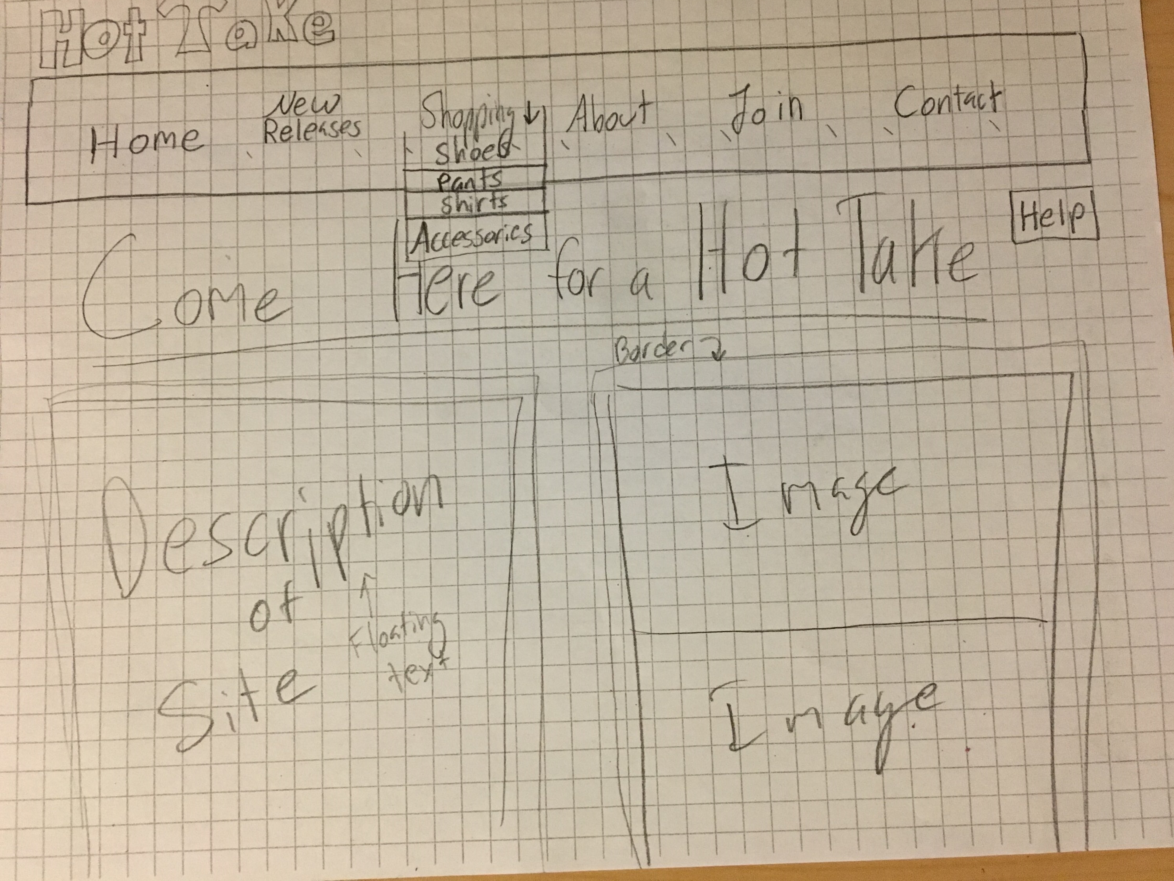

# Requirements

1. *Posted* – All files will be located in the www-root/cs008/final folder of your uvm Silk account. The lab web page and the submit process will detail the exact location. Failure to have your site located in the correct folder by the due dates will result in a zero on the assignment. Be sure to pay attention to the lowercase letters.
2. *Submitted* – Be sure to submit all files in Blackboard (zipped file is ok).
3. *Site map* – Be sure to update your sitemap (you do not need to link to top, header, nav and footer). When you are done, your sitemap should be structured like this (plus other lab links below it):  
   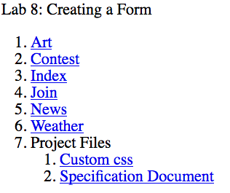
4. *Html Validation* – All pages will pass W3C Html validation for html 5. NOTE: top, header, nav and footer pages will not validate as they are not expected to be viewed by themselves.
5. *Meta Information* – All pages will contain a proper title tag, Meta tags (author, character set and description).
6. CSS Validation – All pages will pass W3C 3.0 CSS validation.
7. CSS – All pages will have a linked style sheet. I am not going to require a specific set of rules but you will be graded on your effort of what you try (just having my sample gets you a zero).
8. *Head Section* – Put the doctype and head section information in a file named top.php so you can include it all the pages.
9. *Navigation* – All pages will contain navigation to all other pages on the site using an ordered list. File name should be nav.php
10. *Content* – The index page will have a minimum of 500 words not counting titles, lists or links that introduces your site and encourages me to want to join. Be sure to use the correct elements to hold your content. The form page does not need to meet this requirement.
11. *Header* – All pages will contain a header. You need to add a logo to fit your site (be sure to use the figure element). File name should be header.php which you will include on all pages.
12. *Form* - We want to entice people to fill out our form so the home page content should do just that. The form will follow my sample on GitLab.
13. *Form* – Will contain fieldsets, legends, input type text for email address and a submit button. Code will include documentation as shows on GitLab.
14. *Form* – Will have your email address as the default value as set by php.
15. *Form* – Should be styled with CSS different than my default.
16. *Footer* – All pages will contain a footer with the content determined by you. Filename will be footer.php
17. *Images* – Each page will have a minimum of one image. Each image will be in the figure element with the figcaption element if needed. The form page does not need to meet this requirement.
18. *Footer* – All pages will contain a footer with your name. Be sure to use the correct element to contain the footer.
19. *File Names* – The form page should be called form.php. All other files keep the name they had before.
20. *Specification Document(this file)*: must be updated and saved as a specs.pdf (must use pdf format and correct filename in the same folder to be graded).